**MICROPROCESSOR AND MICROCONTROLLER-BASED DESIGNS**

**PROJECT FINAL REPORT**

**TEMPERATURE SENSOR USING MICROCONTROLLER**

**PROGRESS WEEK 1: DIGITAL THERMOMETER**

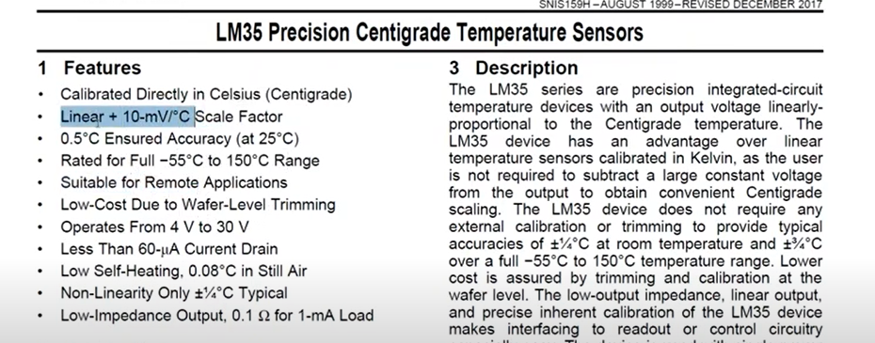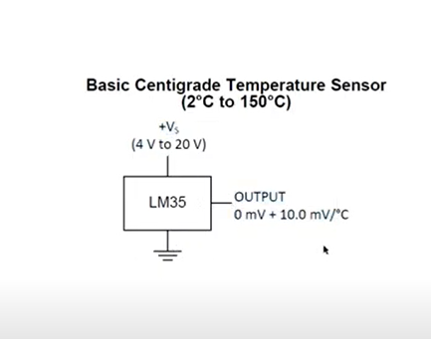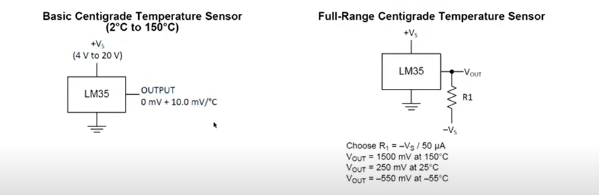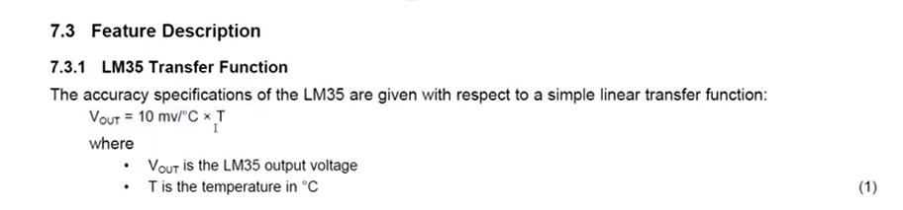

**EQUIPMENT USED:**

* PIC18F452
* LM35 (Temperature sensor)
* Potentiometer 10k
* Resister 1k
* Wires
* LCD 16X2
* Crystal oscillator 4Mz
* Capacitors 22pf

**COMPILER USED:**

* The compiler we used in this project is **MIKROC PRO 7.6.** The reason is that it is the best compiler for microcontrollers in C language.

**C LANGUAGE CODE:**

|  |
| --- |
| // connections between lcd and pic sbit LCD_RS at RC3_bit; sbit  LCD_EN at RC2_bit; sbit LCD_D4 at RC4_bit; sbit LCD_D5 at RC5_bit; sbit LCD_D6 at RC6_bit; sbit  LCD_D7 at RC7_bit;    //directions  sbit LCD_RS_Direction at TRISC3_bit;  sbit LCD_EN_Direction at TRISC2_bit; sbit LCD_D4_Direction at TRISC4_bit; sbit  LCD_D5_Direction at TRISC5_bit; sbit  LCD_D6_Direction at TRISC6_bit; sbit  LCD_D7_Direction at TRISC7_bit;      //prototype void  mydelay(int); unsigned int AD_Read(); void  ADC_ini();      char tp1[7]; char tp2[7]; unsigned int temp_celc; unsigned int temp_kel;    void main()  {  TRISA=0xFF;  lcd_Init();  mydelay(10); lcd_out(1,1,"Temperature is:-"); mydelay(10); delay_ms(500);  while(1)  {  ADC_ini();  temp_celc= AD_read()*0.489;  temp_kel=temp_celc + 273; IntTostr(temp_celc,tp1);  IntTostr(temp_kel,tp2);  Lcd_Cmd(_LCD_CLEAR);  Lcd_cmd(_LCD_FIRST_ROW);  Lcd_cmd(_LCD_MOVE_CURSOR_LEFT);  mydelay(2); lcd_out(1,1,tp1); lcd_out(1,7," C"); mydelay(10); lcd_out(2,1,tp2); lcd_out(2,7,"K");  lcd_cmd(_LCD_CURSOR_OFF);  mydelay(5000);  }    }    void mydelay(int del)  {  int n=0; int  b=0; for(; n<del; n++)  {  for(; b<1000; b++){int s=0;}  }  }      void ADC_ini()  {  ADCON0=0b11010101; //RC OSC, CHANNEL 2, GO=1, ADC ON ADCON1=0b10000000; //Right justified, vref=5 volt mydelay(600);  }  unsigned int AD_read()  {    unsigned int ADC_RES=0;  while(ADCON0.DONE=1){};  ADC_RES=ADRESL;  ADC_RES|=((unsigned int)ADRESH)<<8; return ADC_RES;  } |

**PROGRESS WEEK 2: DIGITAL THERMOMETER**

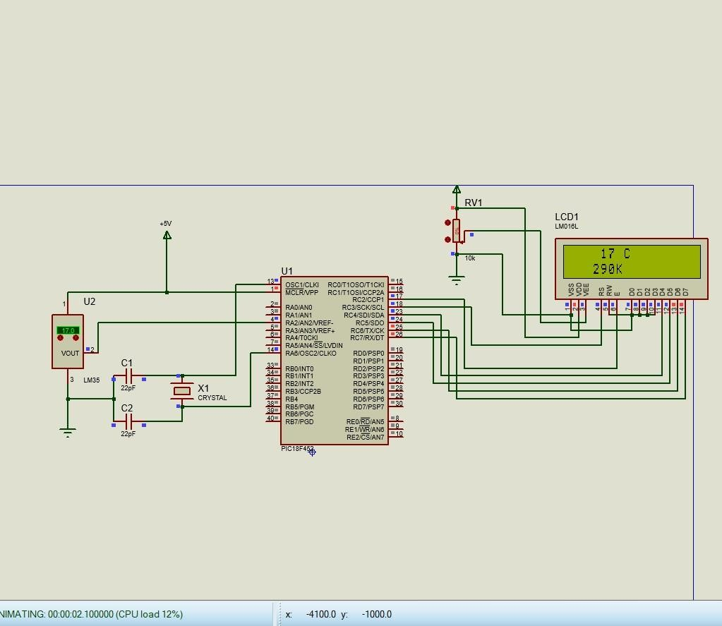

**PROGRESS WEEK 3: DIGITAL THERMOMETER**

**PROGRESS WEEK 4: TEMPERATURE SENSOR**

**EQUIPMENT USED:**

* Arduino-UNO
* LM35 (Temperature sensor)
* Resisters 100ohm
* Wires
* Red and Green Led

**COMPILER USED:**

* ARDUINO is a very handy and very powerful Integrated Development Editor that will let you write code as well as upload it to an Arduino board for testing purposes. This cross-platform IDE works along with an Arduino controller for writing, compiling as well as uploading the code to the board.

**CODE:**

|  |
| --- |
| #define LM35 A0  int GREEN=7;  int RED=6;  void setup()  {  Serial.begin(9600);  pinMode (7,OUTPUT);  pinMode (6,OUTPUT);    }  void loop()  {  float Imvalue = analogRead(LM35);  float temp=(Imvalue*500)/1023;  Serial.println(temp); //Temperature in clecius  delay(1000);  if (temp>60)  {  digitalWrite(GREEN,LOW);  digitalWrite( RED,HIGH);  }  else  {  digitalWrite(GREEN,HIGH);  digitalWrite(RED,LOW);  delay (200);  }  } |

**CONNECTIONS:**

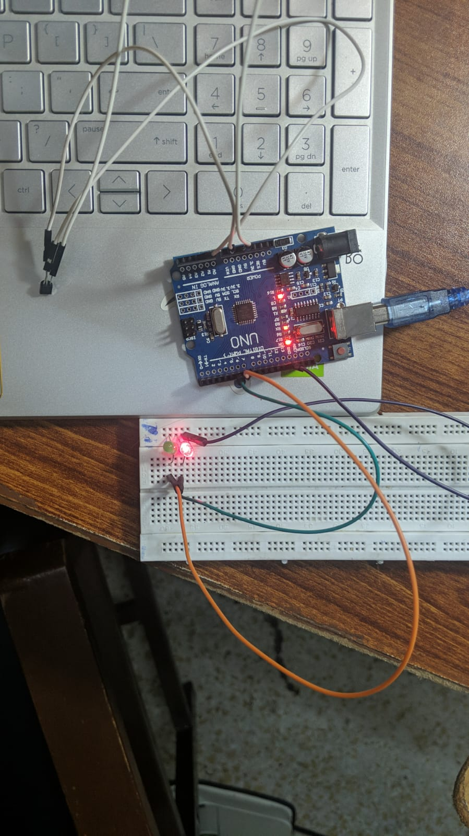

1) Connect the Components as per the Schematic Circuit Diagram

2) Upload "Lm35.ino"

**OUTPUT:**

1. **Verify code**
2. **Upload code**
3. **Open screen monitor**

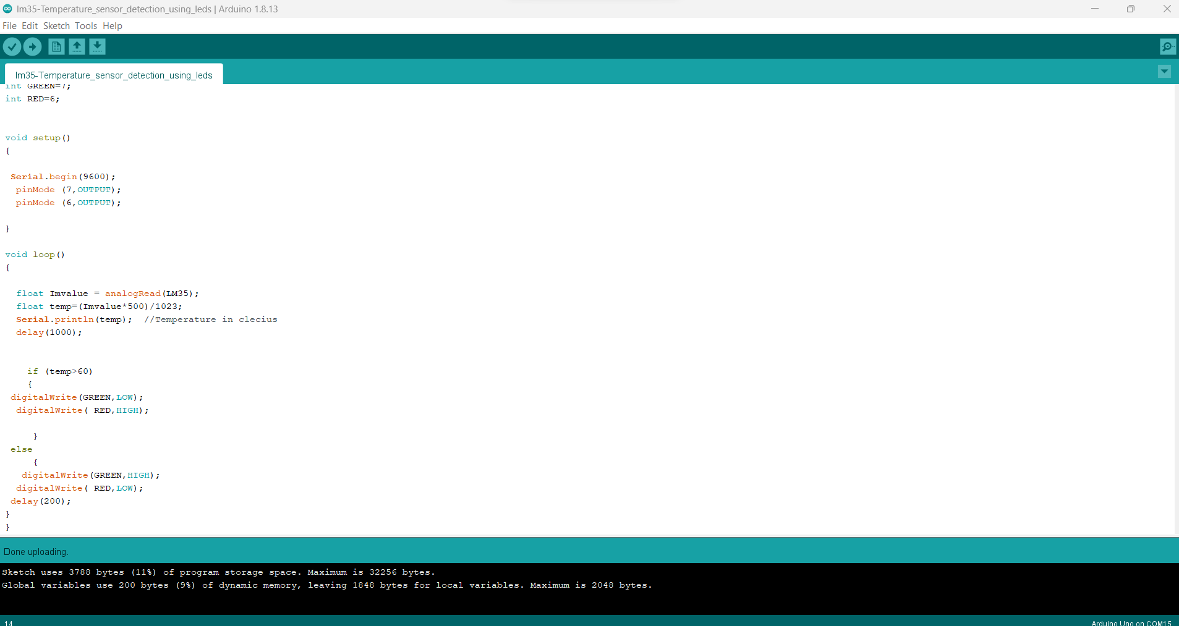

**SCREEN MONITOR OUTPUT:**

**PROTEUS SIMULATION:**

Once we increase the temperature beyond the limit(30) Then led starts to glow.

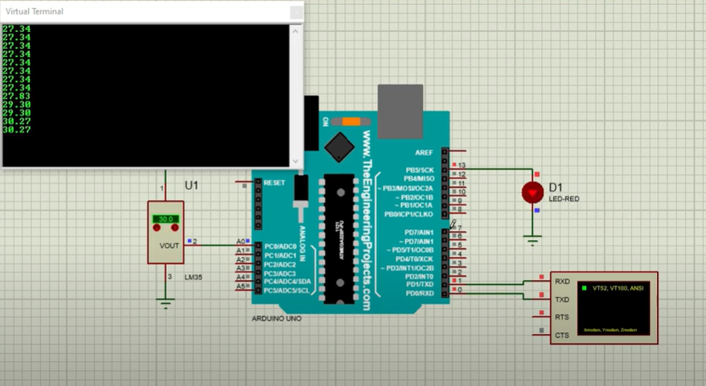

Likewise, if we decrease temperature Led stops glowing.

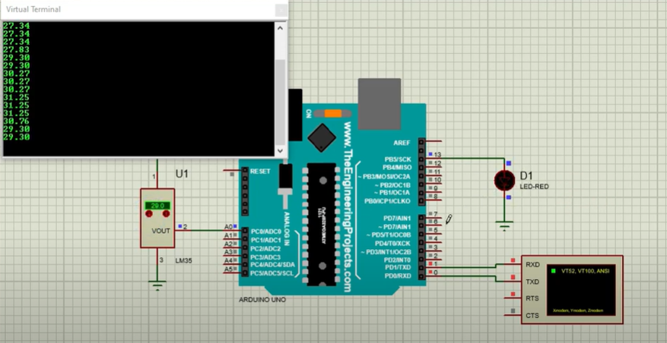

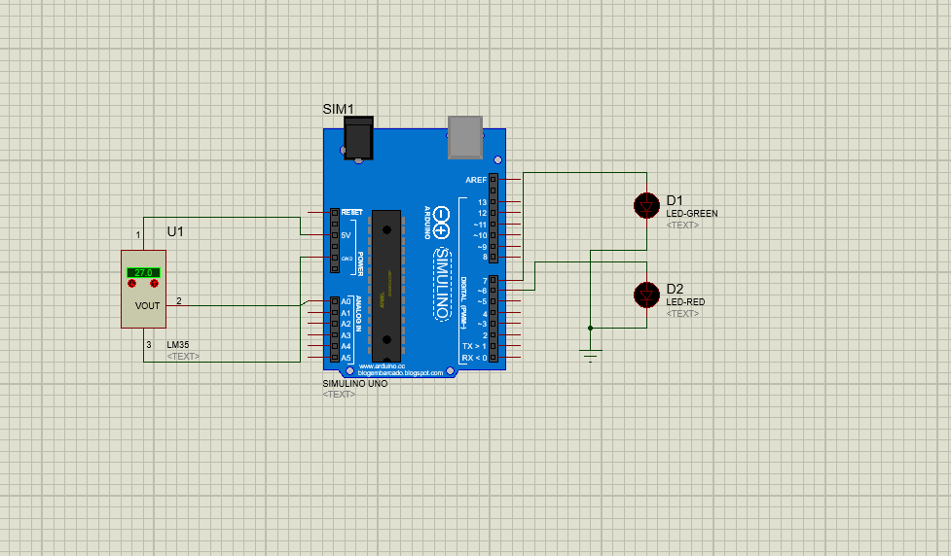

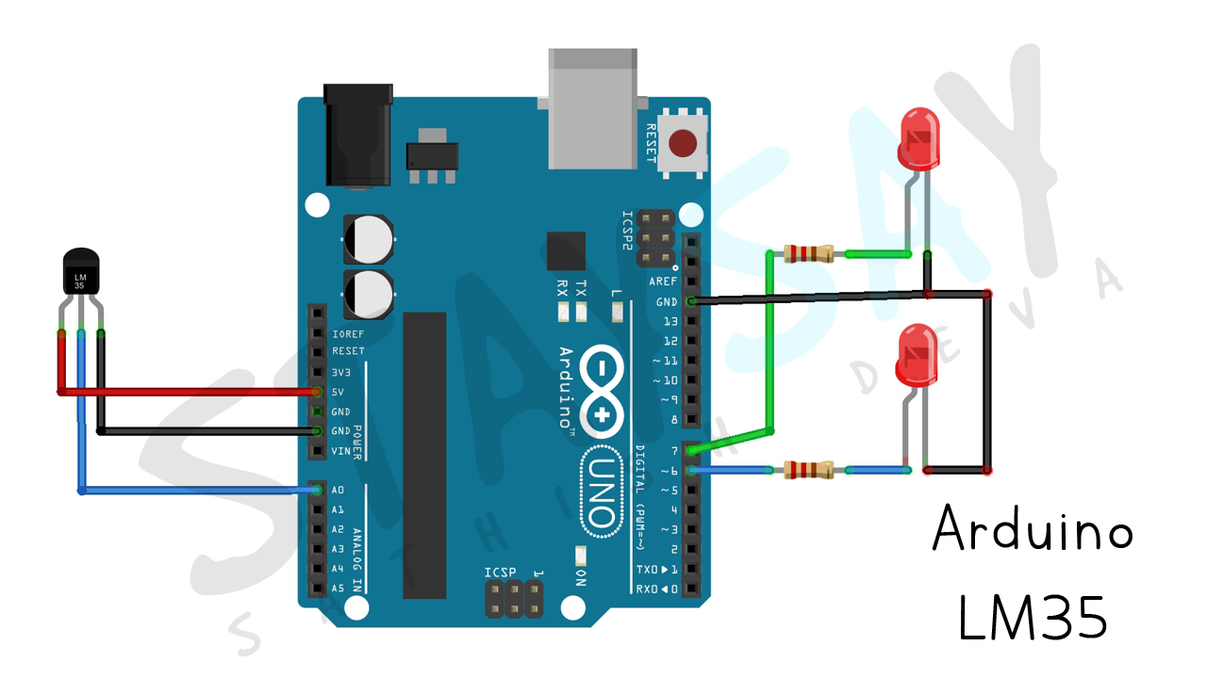

**LIMITATIONS:**

The project does not give negative temperature just a low and high indication.

No Lcd display implemented.